Chapter 8, Solution 35.

Using Fig. 8.83, design a problem to help other students to better understand the step response of series RLC circuits.

Although there are many ways to work this problem, this is an example based on the same kind of problem asked in the third edition.

Problem

Determine v(t) for t > 0 in the circuit in Fig. 8.83.

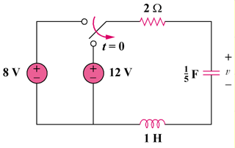

Figure 8.83

Solution

At t = 0-, i_{L}(0) = 0, v(0) = v_{C}(0) = 8 V

For t > 0, we have a series RLC circuit with a step input.

- = R/(2L) = 2/2 = 1, ω_{o} = 1/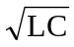 = 1/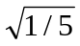 = 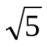

s_{1,2} = 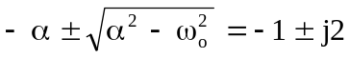

v(t) = V_{s} + [(Acos2t + Bsin2t)e^{-t}], V_{s} = 12.

v(0) = 8 = 12 + A or A = -4, i(0) = Cdv(0)/dt = 0.

But dv/dt = [-(Acos2t + Bsin2t)e^{-t}] + [2(-Asin2t + Bcos2t)e^{-t}]

- = dv(0)/dt = -A + 2B or 2B = A = -4 and B = -2

v(t) = {12 – (4cos2t + 2sin2t)e^{-t} V.

